# MLE-10 Project Proposal

| **Project Title** | Automating Explainability in Healthcare |
| --- | --- |
| **Industry Sponsorship (if Any)** | Samsung SDS Research America |
| **Team Size** | 2 |
| **Member names** | Pedram, Shai |
| **Submission Date** | November 14, 2022 |

## 

## Project Description

### Problem definition

*50-100 word description of the problem which you will solve*

| Diagnosing breast cancer requires a gold standard histopathological confirmation; conducted by a pathologist who microscopically visualizes dissected tissue. The analysis of the specimen results in a diagnosis and stage if positive, with a justification of observed findings. AI models trained on object detection/segmentation tasks are currently used as a diagnostic tool, as they provide precise and consistent predictions. However, the explanations from these models, such as heatmaps, similar images and high level features, do not match those of an experienced pathologist. Explainable features that are suitable for histopathological image diagnosis need to be defined. The data annotations and choice of models needs to be designed to generate accurate diagnostic predictions with high quality explainable features. The annotation and explanation process involved could be more precise and consistent with accurate diagnostic algorithms that identify specific and measurable morphological abnormalities that reflect a carcinoma based on objective annotations. |
| --- |

### Key Research Questions/ Technological constraints that the Project will Answer

| 1. Replicate state of the art explainable features (heat maps, similar images in training data, high level image features) for object detection/segmentation based prediction models, and identify suitability and limitations to histopathological images for cancer diagnosis. 2. Implement other well known, model agnostic explainable features such as LIME and SHAP with histopathological images and determine suitability & limitations, to improve explainability on previous models, and satisfy physician and patient end-users. 3. Does increasing a training data set size and any other factors in dataset/annotations improve explainability in this case? 4. (optional) Explore use of additional text annotations from pathologists, characterising the malignant patches to generate textual descriptions for predictions. 5. (optional) Explore use of anomaly detection and/or graph neural networks instead of object detection/segmentation to improve accuracy of diagnosis and explainability. 6. Perform detailed literature survey for the state-of-the-art techniques for explainability in histopathological images for breast cancer. |
| --- |

### Deliverables

*List the desired technical deliverables from the project team in as much detail as possible*

| 1. ML web application    1. Facilitates the execution of the model that capable of assessing whole-slide images of potentially cancerous breast tissue producing a diagnosis    2. Helps in visualizing the generating corresponding auto-generated explanation reports 2. Python notebook with source codes showing experiments and results on all explainable features considered. 3. ML model detection accuracy metrics    1. F1, Accuracy, precision, recall, ROC/AuC, CM 4. Literature review of state of the art explainable features for histopathological images for breast cancer. |
| --- |

### Key activities/ technologies

*E.g. What kind of technology stack will you work with, the datasets you may need to work on, what kind of analysis you may be expected to undertake, etc.*

| * Morphological Diagnosis   + Large datasets of 50x50 pixel RGB digital images of H&E-stained breast histopathology samples,   + labeled as either IDC or non-IDC images     - <http://web.inf.ufpr.br/vri/breast-cancer-database>     - <https://ieeexplore.ieee.org/document/7312934>     - <https://doi.org/10.1038/s41551-022-00929-8>   + Images will be transformed into Numpy arrays and saved as a .npy file   + Corresponding annotations and labels to be stored a .npy as an array   + ConvNet model is trained to be called by LIME for model prediction later   + +/- Generative adversarial networks (GANs) for anomaly detection * xAI   + LIME image explainer to explain the IDC image prediction results of the 2D Convoluted Network model of Invasive Ductal Carcinoma of the breast from digital pathology slides. |
| --- |

### Expected learning outcomes

*What do you expect to learn from the project? Mention technical skills you will imbibe*

| 1. Quantifiable methods of improving explainability in health AI diagnostics using computer vision 2. Metrics that appropriately reflect accuracy (i.e. heatmaps, ROC, F scores) 3. ML Methods of optimizing diagnostic accuracy 4. Ensuring FAIR principles and patient identity protection |
| --- |

## Tentative Time plan

*Submit a tentative time plan (table/chart or text) regarding breakdown of the work that will be conducted between in the second half of your cohort, from week 6 onward.*

| **Time** | **Milestones** |
| --- | --- |
| November 10, 2022 | Literature review complete  Workflow and pipeline design  Accessing and evaluating datasets  Evaluating best fit models  Evaluating xAI models  Sanity check |
| Dec. 2022 | Data Analysis (cleaned, labelled, annotated)  Prepare an EDT report  Training model |
| Jan. 2023 | Testing model  Quality metrics  Accuracy metrics  Code review and optimization |
| Feb. 2023 | Present demo |

## System Design

From the System design perspective, outline the following:

### Data

* 1. Our dataset will be split as follows: 80% training and 20% testing
  2. Images will include 2,000 H&E-stained digital tissue slides ( 700 x 460 pixels)

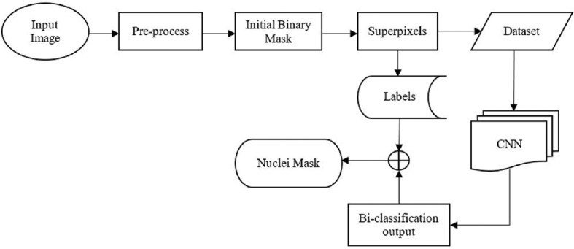

* 1. Object detection with bounding box/circle for ROI (regions of interest)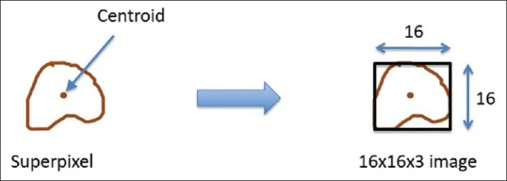
  2. Binary labels (non malignant vs. malignant - IDC)
     1. Later ordinal labels could be applied for other types of breast malignancies



### Process

* 1. A KerasCNN to act as a wrapper to the 2D ConvNet model as a sklearn pipeline component (so that it can be combined with other data preprocessing components such as Scale).
  2. The workflow process will include using pre-annotated images, running them through the object detection pipeline, conducting a review of detection using accuracy metrics, then clustering and reviewing the algorithms for detection and explanations.
  3. A Covariance-Kernel Descriptor (CKD) - a patch level descriptor that compactly describes tissue architectures associated with malignant areas in Cancerous Tissue Recognition (CTR) and an Annotated Image Descriptor will be geared toward larger slide regions to capitalize on the CKD.

### Outcome and recommendations

*What are the system design considerations for your deployable ML model?*

* Iterations
* Delivery Formats
  + The final product can employ a consumer GUI to use an API portal to acquire the WSI from outside parties. An analysis of the WSI can be sent back to the software through the same API portal.
  + Email delivery is another option; however, the searchability of the data can be difficult for the end users.
* Limitations
  + Annotations of WSIs can be challenging. Using field experts to annotate the data can be time consuming and costly.
  + Using different setting for taking WSI images can result in different lighting, coloring, positioning, etc for the images
  + Available datasets can come in formats that are not supported by available packages for the used language (ex: python)
* Solutions to Limitations
  + Obtaining additional reliable annotated datasets from interested parties
  + Creating a baseline for the image attributes (ex: ISO, FL, etc) quantitatively to be used in scanning/ taking pictures
  + Postprocessing of WSI files to match an average desired level of attributes in an image file
* Should the model be deployed to run in batch, or to be hit from an api or some sort of streaming process as events are generated?
  + Depending on the
  + batch
* What sort of infrastructure will be required for training?
  + Depending on the size of the input database and model complexity, the hardware requirements can vary vastly. Using local machines can impose a risk of running the models slowly and scalability is costly. Most of the online services have scalability options. Some easier to implement than the other. AWS, GCP and Azure all have easily accessible options to scale the hardware. From the software standpoint, there won’t be much of a difficulty to add required libraries and dependencies.
* If it is a model that requires a lot of resources, where is the best place to train?

Options:

* + Sagemaker (additional features such as data labeling and further training and deployment abilities, no interruption, non intuitive)
  + Azure notebook (Intuitive environment, persistent model run)
  + Google Colabs (Easy to set up, intuitive environment for collaboration, pre-configured environment)
  + Kaggle (Similar to Colabs, slightly faster than Colab)
  + Local machine (Minimum cost for a small scale dataset, scalability can be very costly)
  + Perspective Gradient (fast storage, on-demand containers and datasets)
  + Conclusion: Google Colab is better for prototyping and is a more convenient choice for team work. However, in the later stages of the project, for data crunching, we can move to Sagemaker for better hardware infrastructures and uninterrupted code execution.

## Ethical Considerations

*Are there any ethical considerations of your project? Consider the data source, the intended outcome, and/or the eventual use cases.*

This project does not declare any ethical conflicts, and has been designed based on the FAIR Principles.

*Findable*

* (Meta)data are assigned a globally unique and persistent identifier
* Data are described with rich metadata
* Metadata clearly and explicitly include the identifier of the data they describe
* (Meta)data are registered or indexed in a searchable resource

*Accessible*

* (Meta)data are retrievable by their identifier using a standardised communications protocol
* The protocol is open, free, and universally implementable
* The protocol allows for an authentication and authorisation procedure, where necessary
* Metadata are accessible, even when the data are no longer available

*Interoperable*

* (Meta)data uses a formal, accessible, shared, and broadly applicable language for knowledge representation.
* (Meta)data use vocabularies that follow FAIR principles
* (Meta)data include qualified references to other (meta)data

*Reusable*

* (Meta)data are described with a plurality of accurate and relevant attributes
* (Meta)data are released with a clear and accessible data usage license
* (Meta)data are associated with detailed provenance
* (Meta)data meet domain-relevant community standards

### Data source

* + All datasets have no personal identifiers and are shared as open-source annotated digital images (metadata is without identifiers)

Datasets:

### Intended Outcomes

* The intention is to allow end-users to upload digital histopathology and acquire a diagnosis without bias
* Based on these considerations, this model will also not allow for personal identifiers in the metadata
* Potential issues that may arise include any black box elements that reduce explainability, and the medicolegal implications of an inaccurate diagnosis.